1.Design DFA to accept bcaaaaaaaaaaaaaa, bc, and c

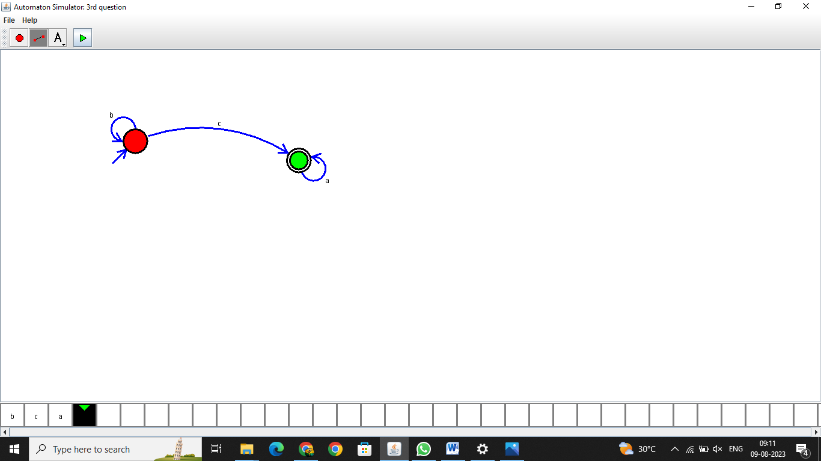

Result:-

The output has been successfully verified

2.Design NFA to accept aaaaaa

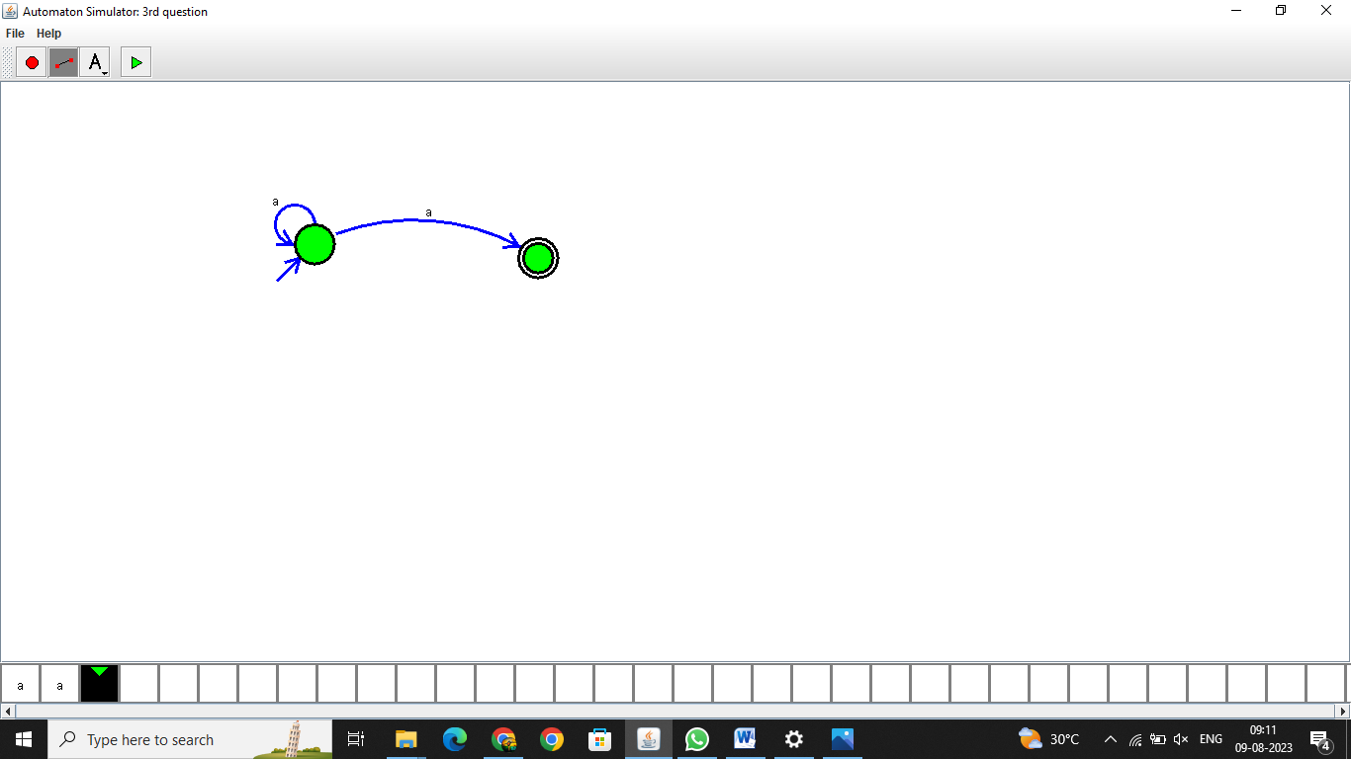

Result:- The output has been successfully verified

3.Design PDA for the input a^nb^n

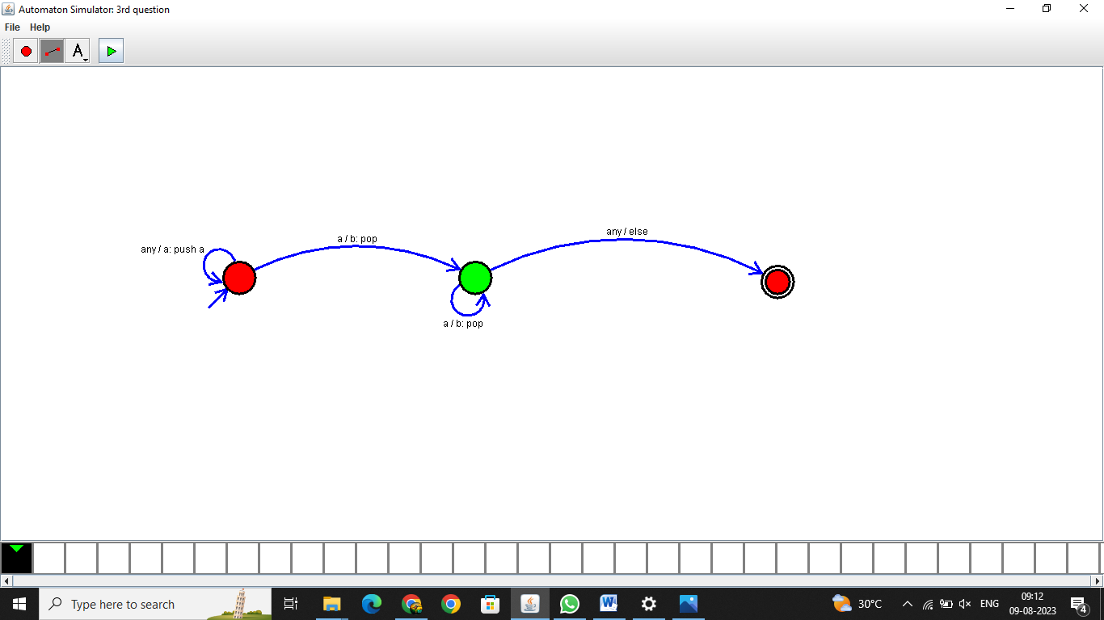

Result:-

The output has been successfully verified

4.Design Tm For input a^nb^n

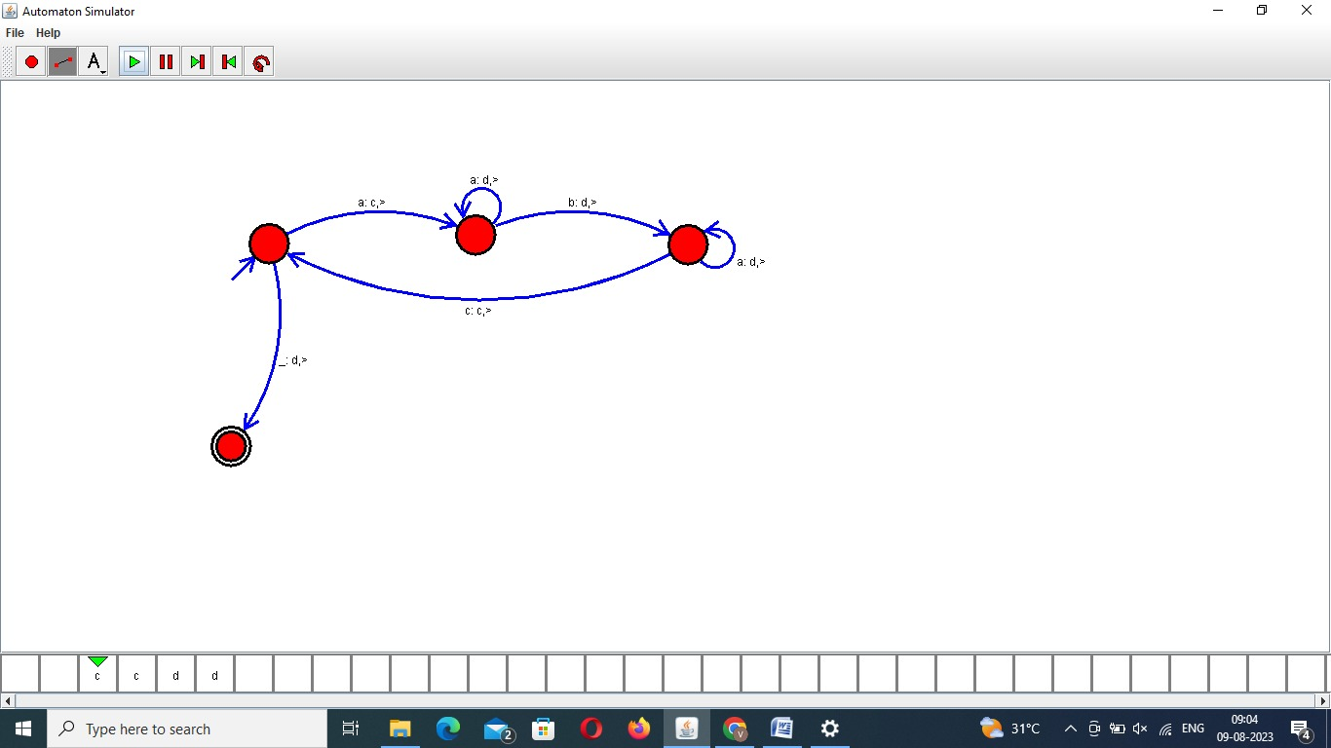

Result:- The output has been successfully verified

5 .Design PDA for input aabbbbc ( L=a^nb^2n)

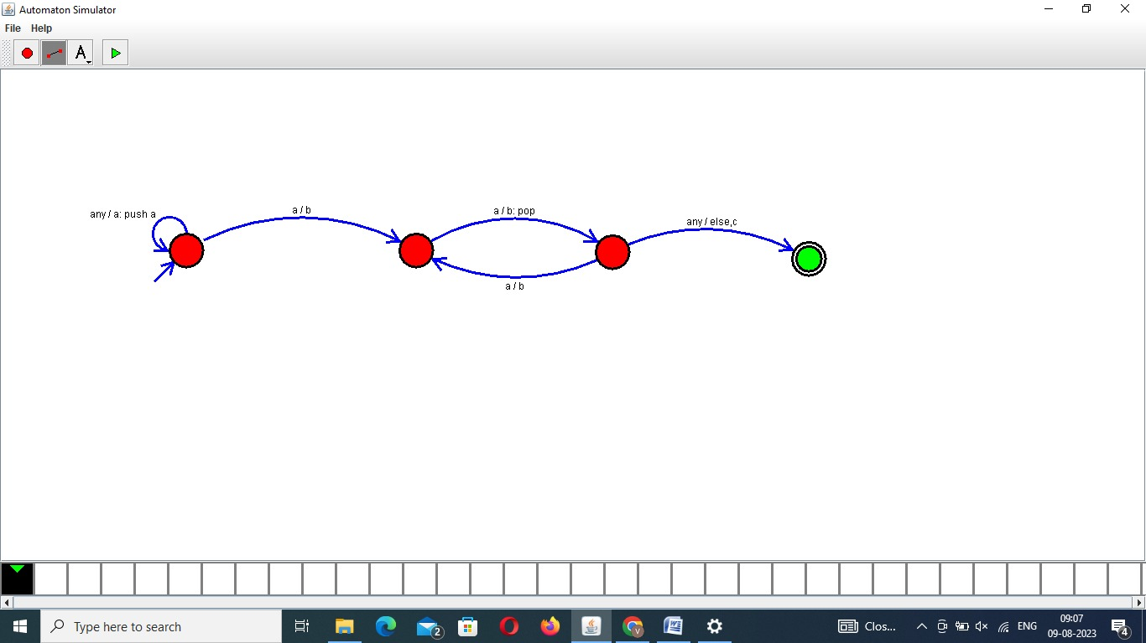

Result:- The output has been successfully verified

6.TM Simulation for Palindrome W= ababa c

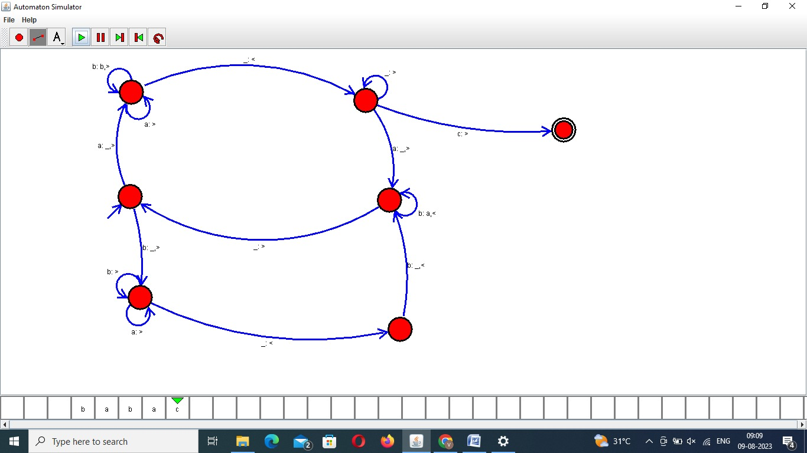

Result:- The output has been successfully verified

7.Design TM to perform addition of following

W= aa + aaaa

After Addition of a’s = aaaaaa

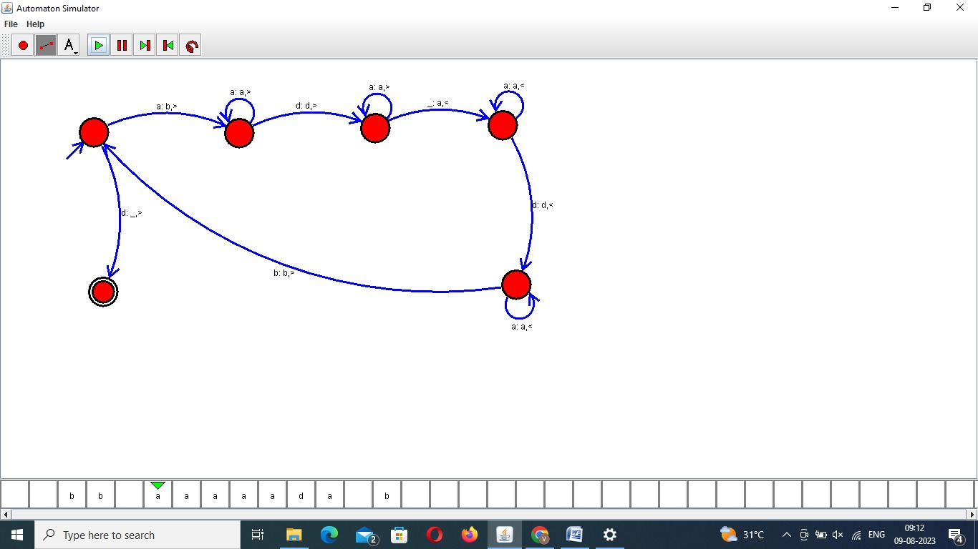

Result:-

The output has been successfully verified

8.Design TM to perform subtraction

W= aaa-aa

The Result of Subtraction is = a

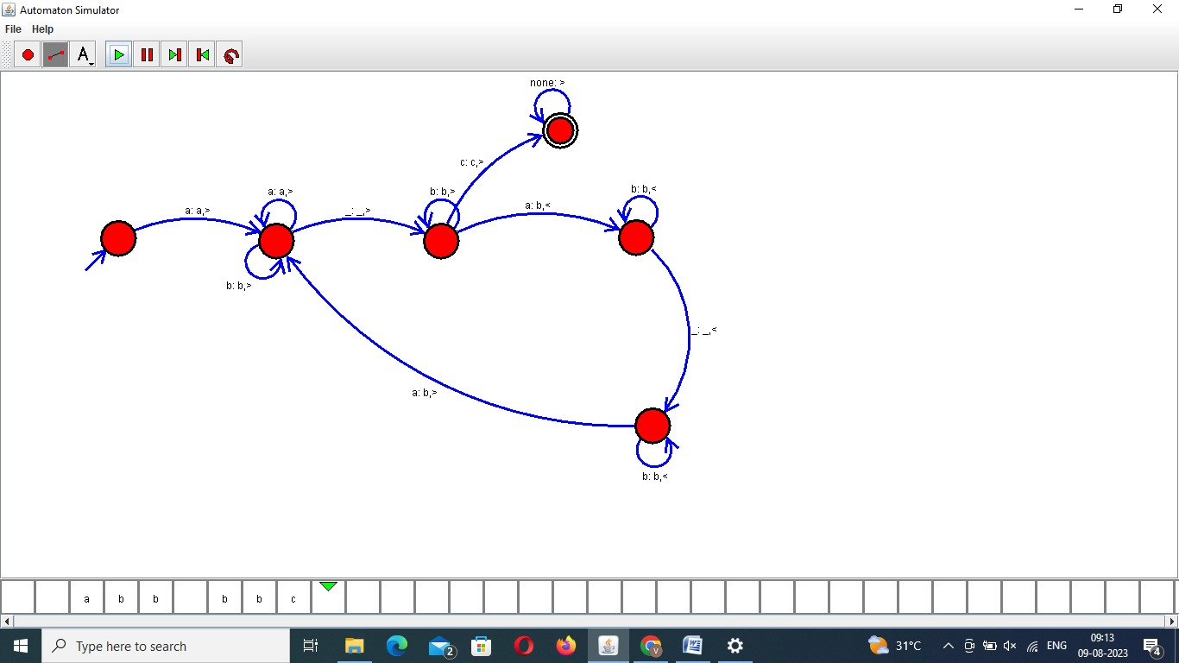

Result:-

The output has been successfully verified

9.Design TM to perofrm string comparison

W = aba aba

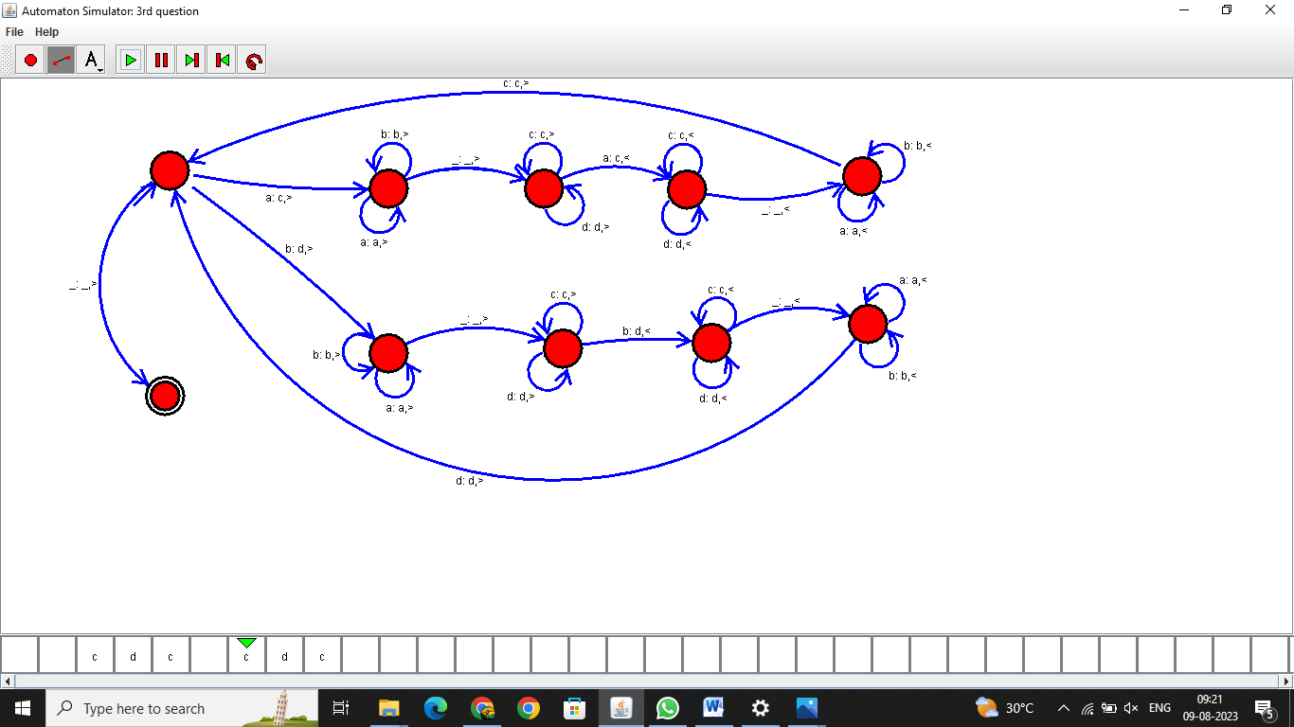

Result:-

The output has been successfully verified